Web Questionnaires service
Developers Manual
Prepared by
Enriko Käsper, TripleDev
February 2015
Version 1.0
User Manual
Version management
No | Date | Changes | Author
1.0 | 22.04.2015 | Creation of the document and migrate the chapters from “AngularJS webforms - getting started” document created by Michael Noren | Enriko Käsper

Contents
1. Introduction 4
1.1 Purpose 4
1.2 Overview 4
2. Webform creation process briefly 6
3. Create webforms 7
3.1. Create webform in AngularJS 7
3.1.1. XML – JSON conversion 8
3.1.2. Using code lists 9
3.1.3. Using Handsontable 9
3.2. Create webform in XForms 11
3.2.1. XForms skeleton 11
3.2.2. Empty instance file 12
3.2.3. Save instance file 13
3.2.4. Save instance to different XML file 15
3.2.5. Code lists and reference files 15
3.2.6. Multilingual webforms 16
3.2.7. Migrate webforms from WebQ1 to WebQ2 19
3.3. Setting up a webform in WebQ 20
3.3.1. Create webform project 20
3.3.2. View webform project folder 21
3.3.3. Upload webform 22
3.3.4. Upload reference files 23
3.3.5. Test the webform in WebQ 24
3.3.6. Test the webform in CDR 25
3.4. Manage XML merging scripts 26

Introduction

Purpose
The purpose of this document is to describe the functionality and technical aspects of the Reportnet Web Questionnaires service (WebQ) and to guide the webform developers through the process of how to create and set up new webforms in EEA's Reportnet infrastructure to facilitate data reporting process for different obligations. The document also describes the integration details between the service and the other Reportnet applications, in particular Central Data Repository (CDR) and Business Data Repository (BDR).
The document is mainly targeted for software developers implementing webforms for different dataflow projects at EEA and for the WebQ service developers and administrators. But also product owners of EEA's dataflow projects can find some hints from the document of how to verify the webforms project configuration in WebQ service.

Overview
The WebQ service allows data reporters to deliver data in XML files using online webforms. Data reporters do not need any other special software for filling in data, but a standard web browser with Javascript support. There are two options of how to deliver data using webforms:
- the reporters can use WebQ anonymously and store the data files locally in their computers. This option is needed when the reporters do not have permissions in CDR envelopes to submit the delivery (eg. regional reporters). In this case the national coordinators with CDR access rights collect the regional XML files (eg. via e-mail), merge the files if needed and upload the files in CDR envelope for submission of the delivery.
- the reporters having applied to reporter role in CDR can access the webforms directly from envelopes via “Add or modify the questionnaire” links. In this case the CDR interacts with WebQ in background and WebQ service produces automatically valid XML files as deliveries in relevant CDR envelopes. The repoters can start to fill out an empty web form or they can pre-fill the web form with data coming from last year’s deliveries, if this option is implemented.

Before the data reporters are able to perform the online reporting, the webform developers have to implement the dedicated webforms based on the reporting obligation specific data definitions and reporting requirements. WebQ service facilitates the implementation of webforms by providing a platform with the following functionality:
- repository for maintaining the webforms
- environment to execute the uploaded webforms
- repository for reference files (codelists, labels) accessible by webforms
- RESTful functions for common concerns, for example
  - download of instance files
  - convert JSON ↔ XML
  - run remote conversions via Conversion Service (XMLCONV)
- integration with CDR by solving the authentication issues

The current version of WebQ supports two different webform technologies:
- XForms technology natively binds the XML elements with fields on web form. The technology allows to easily build up simple questionnaires with ability to load and store the data in XML files. The XForms are converted to HTML in server-side using betterForm XForms engine and served as a standard HTML page in users' web browsers.
- pure HTML forms can be implemented in any client-side programming framework as far as they support standard HTML with Javascript. The webform has to be able to communicate with WebQ using RESTful services for downloading and saving the data in instance files. The data exchange format can be either XML or JSON. WebQ provides the XML to JSON and vice versa conversion out of the box. It is suggested to use any framework with data binding ability to build highly flexible, performant and interactive forms. We've chosen AngularJS to fulfill these target.
The next chapters gives you an overview of how to implement and maintain webforms in both technologies, how to use different server-side functions on webforms and how to integrate the webforms with CDR.
The current implementation of the WebQ service is often referenced as WebQ2 as it is the second version of web questionnaires service. The first version was implemented and relied only on XForms technology using server-side engine called Chiba.

WebQ service is accessible at: http://webforms.eionet.europa.eu/
WebQ source code is maintained at GitHub: https://github.com/eea/eionet.webq

Webform creation process briefly
The related tasks when implementing a new webform for reporting begins with creating a XML schema, matching the reporting requirements. The schema is to be uploaded and published on the Eionet data dictionary (DD). Together with the schema, an empty instance file of the schema needs to be generated.
The next step is to produce the webform, which on a basic level should load this instance of the schema from the server, let the user edit the elements/fields using a regular HTML form, and later save it back to the server. It has to be decided, either to use XForms technology or AngularJS as the implementing language for the new webform. It is rather easy to bind the XML elements on XForms and use it for simple questionnaires, but it gets much more complicated and less performant, when it the functional requirements are complex or the amount of data to be stored in XML is more than tens of kilobytes.
Since the AngularJS webforms interacts better with JSON instead of XML, the instance file is converted on the server to JSON when loaded, and back again when saving.
When the webform is produced, it should be uploaded to the Eionet web questionnaires platform (WebQ). In order to connect the webform with the normal reporting procedures by countries, via the envelopes on Eionet Central Data Repository (CDR), the schema published on DD earlier has to be mapped to the correct reporting obligation in the Reporting Obligations Database (ROD) and also to the webform. The schema–reporting obligation mapping is done in CDR, and the mapping between the schema and the webform is done in WebQ.
Creating the mapping makes CDR recognise that there is a webform in place for this obligation and therefore provide a link for the user to edit an instance file using the webform. On the first edit the instance file will be created and added to the envelope from WebQ, and subsequent edits will update this file. Basically the webform plugs into CDR as a means for editing the XML-file in the envelope, leaving the other steps in the CDR reporting workflow as normal.

Create webforms
WebQ system is able to execute two types of webforms – implemented as pure HTML on AnguarlJS framework or implemented in XForms technology. The main difference between these two types is the format of data model. The underlying data is stored natively in XML format in XForms, while AngularJS stores its' data in JSON format. Another important difference in the implementations is the location of persisted data during webform execution. XForms implementation stores the data entirely in server side in user session attributes in application server memory, while AngularJS stores the data in client side in user webbrowser. Both type of webforms need to persist the data regularly in WebQ system using dedicated API.
WebQ provides automatic conversion between XML and JSON formats, thus most of the API functions are similar for the both types of webforms. Also the setup procedure is similar in WebQ. The next chapters explain how to create webforms in AngularJS and XForms.

Create webform in AngularJS
The quickest route to understand how to create a new webform is probably to look at some of the current ones in the Dataflows subversion repository. For example the Industrial Emissions Directive (IED) webform is quite simple, while the MMR Article 17 webform provides an example of a more advanced tabular form. In principle, a suitable html-form covering the required information specified by the XML schema has to be developed, and the fields has to be hooked into the AngularJS-data model. The next step is to integrate it with the WebQ platform.
Apart from the setup procedure explained further down, the specifics of integrating the webform with WebQ are mainly about how to load and save data from and to WebQ. When someone opens a webform it will be called with a set of parameters:
- The values for “base_uri” and “envelope” should be used to get the path for loading additional files, and also return the user to the envelope after closing the webform.
- The parameter “fileId” is the identifier for the instance file (new or existing one), and a GET-request needs to be made back to WebQ using the URL “/download/converted_user_file?fileId=<fileId parameter value>”, which will return the user instance file formatted (converted) into JSON. If the user is just starting the reporting in a new envelope without an instance file created yet, WebQ will return a new copy of the empty instance file (created together with the schema earlier).
- Finally, “sessionid” should be appended to the URL on calls for loading and saving the instance data.
After receiving the JSON representation of the instance file, it can now be used as the data model in AngularJS, binding it to the input fields in the HTML-form. When the user has finished editing the form (or just wants to save it), the updated data model can be saved back to the server (envelope) by issuing a HTTP POST-request with the JSON-representation of the instance file to the URL “/saveXml?fileId=<fileId parameter value>”. When the user closes the webform he/she should be redirected back to the envelope-URL.
Looking at some of the previous EEA webforms developed with AngularJS, the other main parts of the code are mainly about implementing eventual translations of question labels and code lists, which usually are kept in separate files, informing the user if actions takes time to complete (such as loading the webform), preventing the user from accidentally leaving the form with unsaved data, and of course validation.

XML – JSON conversion
For understanding how the XML-file is represented in the JSON-format received on the client side from the conversion on WebQ, investigating the library used in WebQ (Staxon), and the mapping convention could be useful. To avoid the common pitfalls, there are some issues to keep in mind when doing the XML-JSON conversion:
- If the form has fields, or rows of fields that can be added or removed, measures have to be taken before saving it back to the server to make sure the order of the fields still match the original XML instance file as JavaScript does not guarantee the order of object properties.
- All the attribute properties (starting with “@”) have to go after the main element. Especially the root element attributes cannot be added to the end of the JSON model.
- Th e automatic XML to JSON conversion does not create array object if only one element exists. They have to be converted to arrays in the webform JavaScript code.
The WebQ service also provides additional methods that can be useful when producing a webform:
- XML-files in the webform project folder can be downloaded in JSON format by appending a “format=json”-parameter to project file URL, e.g. “/download/project/ied/file/ied-instance-empty.xml?format=json”
- Additional information about a webform can be retrieved by calling the URL “/file/info?fileId=<fileId parameter value>”, e.g. “http://webq2test.eionet.europa.eu/file/info?fileId=2674”. This information will be in XML format though.
- Any conversion service registered with the Conversion Service via the webforms underlying XML Schema can be used by calling the url: “/download/convert?fileId=<fileId parameter value>&conversionId<conversionId>”.The list of conversions registered for the webform can be found in the response from the Info-call described above.

Using code lists
The preferred way to implement the code lists often needed for the webform’s question labels and values for fixed choices, is to have these lists published on DD in JSON-LD format and use them directly from there in the webform. One example that is simple and understandable is the countries vocabulary, where the consuming webform needs to iterate over the list of concepts to retrieve each country-ID from the “@id”-property and the language specific label from the “@prefLabel”-property. It is possible to limit the result by appending a “lang”, “id” or “label” parameter to the URL. For how this can be consumed through a webform, see the Habides webform. Besides using the code lists from DD, the reference files can be uploaded to WebQ webform project file area. Webforms can access these files using relative URLs.

Using Handsontable
Handsontable is a minimalist Excel-like data grid editor for HTML & JavaScript. The usage of Handsontable on webform simplifies copying and pasting bulk data from MS Excel to webform and vice versa. This is quite common requirement for data reporting applications. Although Handsontable provides basic cell-level data validation mechanism, then in many cases it may not be enough to satisfy more complex data validation requirements. Also displaying of validation messages in a user-friendly way could be achieved more easily, when implementing Handsontable view as an alternative view to the "default" read-only view (eg. list of reports).
The solution was implemented in Large Combustion Plants webform in #18614. In this project we experienced that around 1000 rows is optimal number of rows to perform efficiently even in IE 9. We have identified slight inconveniences when copying boolean and numeric fields from Excel to webform user have to be aware of:
- decimal values have to use points instead of commas
- columns containing checkboxes accept only "true" or "false" (in lower case) values. “True”, “TRUE”, “Y”, “1” won’t work. Instead they will generate “#bad value#”.
- cannot copy and paste values into read-only fields
- the values (codes) of select boxes are copied instead of selection label, which is the correct solution in technical perspective. But the users might be confused, if they don't see the real value of selection after copying and pasting.
NB! The Handsontable latest version 0.12.x has dropped supporting IE 8 and 9.
Handsontable v. 0.11.4 scripts and css files are part of WebQ source code. They are accessible from webform:
<!-- Handsontable JS and CSS -->
<link rel="stylesheet" media="screen" href="../../../../js/handsontable/0.11.4/jquery.handsontable.full.css">
<script src="../../../../js/handsontable/0.11.4/jquery.min.js"></script>
<script src="../../../../js/handsontable/0.11.4/jquery.handsontable.full.js"></script>
<script src="../../../../js/handsontable/0.11.4/numeral.de-de.js"></script>
The reference implementation of how to use Handsontable on AngularJS webform can be found in LCP webform.
At first you have to define the Handsontable Angular JS directive, where you can bind your data and configure the behaviour and appearance of Handsontable:
app.directive('uiHandsontable', function () {
return {
restrict: 'A',
scope: {
data: '='
},
replace: true,
link: function (scope, elem, attrs) {
scope.$watch('status', function(newValue, oldValue) {
if(newValue == true && angular.isArray(scope.data)){
elem.handsontable('loadData', scope.data);
}
});
var data = scope.data;
var formname = scope.formname;
var container = elem;
handsontable({
data: data,
contextMenu: false,
rowHeaders: false,
columnSorting: false,
stretchH: 'all',
fixedColumnsLeft: 2,
minSpareCols: 0,
miSpareRows: formname === 'ListOfPlants' ? 1 : 0,
colHeaders: getHandsontableColHeaders(formname),
columns: [{data: "PlantName"}, {data: "PlantId", readOnly: true}, ...]
});
}
}
});

Then you can use this directive in HTML div, where Handsontable library draws the editable table:

The solution is inspired by AngularJS directive for Handsontable implemented in https://github.com/handsontable/ngHandsontable.
<div id="elemId" ui-handsontable data="instance.Report" class="handsontable"></div>

Create webform in XForms
WebQ supports webforms implemented in a language conforming to W3C XForms 1.1 specification. To build up a webform with XForms, then everything you have to do is write XForms tags, attributes and CSS rules in a single XHTML file. You'll not need to write any Javascript or (beware) Java to make things run. You don't even need to understand how all AJAX, XForms magic is done behind the scenes. But you should have an understanding of XHTML, CSS and basic XForms.
WebQ service uses XForms server-side implementation called betterForm (http://betterform.de) that transforms the actual XForm to HTML page in application server. Pure HTML with javascript is served and executed in client web browser.
Some guidelines for creating and understanding the webforms implemented in XForms language can be found on betterForm demo site: http://demo.betterform.de/
Another route to understand how to create webforms for WebQ platform is to look at the reference implementation of HaBiDes4 webform (https://github.com/eea/eionet.webq/blob/master/src/main/webapp/forms/habides-factsheet-v4.xhtml) or some of the existing webforms in the Dataflows subversion repository. For example VOC Solvents Directive questionnaire or IPPC and WID questionnaires.
It is also useful to review the source code of betterForm engine in GitHub: https://github.com/betterFORM/betterFORM
As the XForms is not a widespread technology, there are not many XForms editors, but ordinary XML editors are good enough for checking the well-formedness of the file.
It is important to remember, although it is possible to create webforms with rather complex functionality in XForms, the technology is still meant for questionnaires manipulating small amount of data.

XForms skeleton
Starting from the scratch you need to create a skeleton for the web form. XForms itself is not a standalone markup language, but it is embedded into the XHTML document. To embed XForms into XHTML you have to watch only a few things:
- put the XForms Namespace on the root Element of your document.
- add a <xforms:model> tag to the head section of your XHTML document (or 'xf' if you have choosen that for your prefix).
The model itself has the following important children:
instance – is the root Element for the data you work with
bind – adds constraints and types to certain selected data nodes
submission – defines loading and saving operations (interaction with some datasource)
action – if you want to listen for events during model-initialization
- add some XForms UI to the body of your document. In this example a <xforms:group>
- bind some of your controls to the model data

Example of XForms skeleton:
<?xml version="1.0" encoding="UTF-8"?>
<html xmlns="http://www.w3.org/1999/xhtml"
xmlns:xf="http://www.w3.org/2002/xforms">
<head>
<title>hello</title>
<xf:model id="hello-model">
<xf:instance id="default" src="http://instanceURL" xmlns=""/>
<xf:submission id="finish" f:action="http://submissionUrl" f:method="post" replace="instance" f:encoding="UTF-8"/>
(..)
</xf:model>
</head>
<body>
<h1>Webform title</h1>
<xf:group>
<xf:input ref=“foo“>
<xf:label>Foo</xf:label>
</xf:input>
</xf:group>
</body>
</html>

Empty instance file
Web form needs to know the location of the default instance file. Usually it is a file stored in the CDR envelope. WebForms service passes the instance file URL to XForms as a context parameter called “instance” and this can be evaluated on XForms as following:

<xf:instance id="default" src="{$instance}"/>

There are cases when the WebForms service does not know the instance file URL. It happens when the file is not yet created into the envelope or the form is activated from the WebForms repository. Since this is the pre-requisite of XForms that it has to know the structure of XML file, then in these cases the location of empty instance file should be written into web form. It can be achieved with the following syntax:

<!-- ########## DEFAULT instance ############-->
<xf:instance xmlns="" id="default">
<derogations/>
</xf:instance>
<!-- instance for EMPTY XML structure -->
<xf:instance xmlns="" id="emptyinstance" src="http://webqdev.eionet.europa.eu/xml/habides-derogations-instance.xml">
<derogations/>
</xf:instance>
<!-- ########## SUBMISSIONS ############ -->
<xf:submission id="load-instance" method="GET" replace="instance" resource="{ instance('context')/instanceUrl }" instance="default" validate="false()">
<xf:action ev:event="xforms-submit-done"/>
<xf:action ev:event="xforms-submit-error">
<xf:message level="modal">An error occurred when loading instance data!</xf:message>
</xf:action>
</xf:submission>
<xf:submission id="load-emptyinstance" method="GET" replace="instance" resource="{ instance('context')/emptyInstanceUrl }" instance="emptyinstance" validate="false()"/>

<!-- ########## ACTIONS ############-->

<xf:action ev:event="xforms-ready">
<xf:setvalue ref="instance('context')/instanceUrl" value="bf:appContext('instance')" if="string-length(bf:appContext('instance')) &gt; 0"/>
<xf:setvalue ref="instance('context')/instanceUrl" value="instance('context')/emptyInstanceUrl" if="string-length(bf:appContext('instance')) = 0"/>
<xf:send submission="load-instance" name="xforms-submit"/>
<xf:send submission="load-emptyinstance" name="xforms-submit"/>
</xf:action>

Save instance file
You should use the submission element that posts the form to WebQ saveXML method for saving the instance file back into CDR envelope. The WebQ knows the logic and credentials of how to store/create the XML into CDR envelope. The response of the request is an XML with some data about save results. Use the following code for saving the data and displaying the save results for user:
<xf:model>

<!--submission for saving XML -->
<xf:submission id="savexml" action="{$base_uri}/saveXml?fileId={$fileId}" method="post" replace="instance" encoding="UTF-8" instance="saveresult" validate="false()">
<xf:dispatch targetid="main-model" name="reset-content-modified" ev:event="xforms-submit-done" />
<xf:message level="ephemeral" ev:event="xforms-submit-done" bind="b-saveresult-message"/>

<xf:action ev:event="xforms-submit-error">
<xf:setvalue ref="instance('saveresult')/code" value="0"/>
<xf:setvalue ref="instance('saveresult')/message" value="'Error on saving data!'"/>
<xf:setvalue ref="instance('saveresult')/timestamp" value="current-dateTime()"/>
<xf:message level="modal">Error on saving data!</xf:message>

</xf:action>
</xf:submission>
<!-- instance for showing save result messages from WebQ system -->
<xf:instance xmlns="" id="saveresult">
<saveresult>
<code desc="Result code: 0-ERROR;1-OK">-1</code>
<message desc="Save result message"/>
<timestamp desc="Result time"/>
</saveresult>
</xf:instance>

</xf:model>

(…)

<body>
<xf:action ev:event="DOMActivate">
<xf:send submission="savexml" name="xforms-submit"/>
</xf:action>
</body>
It's possible to use the following request parameters in save actions:
fileId – (mandatory) user file identificator received from request parameter
title – (optional) sets title attribute in CDR envelope
restricted – (optional – true, false, undefined) if the parameter value is true, the file will be restricted from public view in CDR envelope. If the parameter value is false, the file will be publicly available in CDR envelope. If the value is not specified, then CDR default value is used.
To see more sophisticated examples of file actions, see the reference implementation at:
https://github.com/eea/eionet.webq/blob/master/src/main/webapp/forms/SaveButtonsWithFileInfo.xhtml

Save instance to different XML file
It is possible to store the data in instance file into different format of XML file using XSL transformation. You should use the submission element that posts the form to the same saveXml method. The response data is in XML format having the same structure as save and finish actions have. To be able to use the transformation, xsl parameter should be added with the xsl file name that is stored in Conversion Service xsl repository.
It is possible to use the following request parameters in savexml action:
fileId – (mandatory) user file identificator received from request parameter
filename – (mandatory) If the parameter value is just a file name, then the file will be stored in the same envelope as default instance file. If the parameter value is full URL, then it can be stored another envelope.
title – (optional) sets title attribute in CDR envelope
restricted – (optional – true, false, undefined) if the parameter value is true, the file will be restricted from public view in CDR envelope. If the parameter value is false, the file will be publicly available in CDR envelope. If the value is not specified, then CDR default value is used.
xsl – (optional) Conversion Service XSL stylesheet file name or conversion ID. The XML file will be transformed before storing it into CDR envelope.
Example:
The following example stores the default instance XML into separate file in the same envelope called “confidential.xml”. The file is transformed into another format using “transform_secret.xsl” in Conversion Service before storing it into CDR envelope. Restrict from public view flag is raised in CDR envelope.
<xf:model>

<!-- save the instance to different XML file -->
<f:submission id="savexml" action="{$base_uri}saveXml?fileId={$fileId}&amp;filename=confidential.xml&amp;restricted=true&amp;xsl=transform_secret.xsl&amp;title=Secret%20data" method="post" replace="instance" encoding="UTF-8" instance="saveresult" validate="false">
<message ev:event="xforms-submit-done" ref="instance('saveresult')/message" />
<f:message ev:event="xforms-submit-error">Error on saving data!</f:message>
</f:submission>

...

</f:model>

Code lists and reference files
Web forms consume usually reference data from several XML files. They can contain code lists for elements, translations for UI labels, error messages or empty instance files. WebQ project allows you to store these kind of lookup files in project folder. The lookup files can be loaded into the web form memory using the following code snippet:

<xf:instance xmlns="" id="waste-codes" src="{$base_uri}/download/project/ippc-wi/file/wi_waste_catalogue-en.xml">
<root/>
</xf:instance>

Another option is to load the code lists from Data Dictionary vocabularies. The concepts in each vocabulary are available in RDF format. For example the list of country ISO2 codes is accessible here:
http://dd.eionet.europa.eu/vocabulary/common/countries/rdf

Multilingual webforms
Follow the steps below for making your web form multilingual:
- Define reporting language in instance XML root element using xml:lang attribute
<?xml version="1.0" encoding="UTF-8"?>
<root xml:lang="en">
(...)
</root>

- Create XML file for holding translations of labels – it is easier to maintain the translations and the webform performs much better, if each language is stored in a separate XML file. The lookup file for labels can be in any format, but it is suggested to use some standardised format - eg. TMX (Translation Memory eXchange) (http://www.lisa.org/Translation-Memory-e.34.0.html) that is vendor-neutral open XML standard for the exchange of Translation Memory. The benefits you gain from using TMX format:
  - flexibility of using different translations editing tools
  - the translations are reusable in the next web forms
  - the solution is future proof against technology changes
The example of translations in TMX format:
<tmx version="1.4">
<header creationtool="Manual" creationtoolversion="1.x" datatype="plaintext" segtype="paragraph" adminlang="en" srclang="en" o-encoding="utf-8">
</header>
<body>
<tu tuid="h1">
<tuv xml:lang="en">
<seg>Questionnaire on the implementation of Directive 1999/13/EC</seg>
</tuv>
<tuv xml:lang="fr">
<seg>Questionnaire sur la mise en œuvre de la directive1999/13/CE</seg>
</tuv>
<tuv xml:lang="de">
<seg>Fragebogen über die Durchführung der Richtlinie 1999/13/EG</seg>
</tuv>
</tu>
</body>
</tmx>

If any translation is unknown, then it make sense to use English term in the missing value to make sure that something is displayed on web form. Or the other possibility is to to use “???” in the missing term to be able to find the missing translations later.
In reality, it is usually easier and more optimal to maintain simpler format of XML files, having label id in XML element name and label value in XML element value.
<labels xml:lang="en">
<h1>Title of the page</h1>
<countryCode>Country code</countryCode>
</labels>

- Detect the language on web form xforms-ready event and store the value in helper instance:

<!-- Define context instance and bindings -->
<xf:instance xmlns="" id="context">
<data>
<languageXmlUrl/>
<languageXmlUrlTemplate>/download/project/ippc-wi/file/dir20081ec_labels-XX.xml</languageXmlUrlTemplate>
</data>
</xf:instance>

<xf:action ev:event="xforms-ready">
<xf:setvalue ref="instance('context')/lang"
value="if (count(instance('report-languages')/lang[.=instance('default')/@xml:lang])=0) then 'en' else instance('default')/@xml:lang" />
<xf:dispatch targetid="main-model" name="changeLanguage"/>
</xf:action>

<xf:submission id="load-labels" method="GET" replace="instance" resource="{ instance('context')/languageXmlUrl }" instance="labels" validate="false"/>

<xf:action ev:event="changeLanguage">
<xf:refresh/>
<xf:setvalue ref="instance('context')/languageXmlUrl" value="concat(bf:appContext('base_uri'), replace(instance('context')/languageXmlUrlTemplate, 'XX', instance('context')/lang))"/>
<xf:send submission="load-labels" name="xforms-submit"/>
<xf:recalculate/>
</xf:action>

- Create bindings for labels depending on the selected language
<!-- Define labels instance and bindings -->
<xf:instance xmlns="" id="labels">
<labels/>
</xf:instance>

<xf:bind id="b-labels" xf:nodeset="instance('labels')/labelSet">
<xf:bind id="b-label-q-h1" xf:nodeset="q-h1" />
<xf:bind id="b-label-q-general-notes-heading" xf:nodeset="q-general-notes-heading" />

...

- Bind labels values and form controls

<h1>
<xf:output><xf:label class="heading" bind="b-label-q-h1" /></xf:output>
</h1>

Migrate webforms from WebQ1 to WebQ2
WebQ version was completely rewritten in 2013. The first version of WebQ supports only XForms and it depends on the XForms server-side engine Chiba. The WebQ1 is still operational at http://webq.eionet.europa.eu/. The are number of webforms that needs to be migrated to WebQ2 environment. This exercise has already been done with some of the webforms (IPPC, WID, SED, HaBiDes). Although the both type of webforms conforms to the same XForms specification, there are still some significant differences in different implementations of XForms engines (Chiba vs betterForm) and in different WebQ versions. The following issues need to be fixed when doing the migration exercise:
- Replace chiba's namespace in root element with betterForm's namespace
WebQ1:
<html xmlns:chiba="http://chiba.sourceforge.net/xforms"

WebQ2:
<html xmlns:bf="http://betterform.sourceforge.net/xforms"
- Replace all functions using Chiba's namespace with betterForm functions
WebQ1:
chiba:context('param')

WebQ2:
bf:appContext('param')
- Change XForms 1.0 if() function "xforms:if()" with XPath 2.0 if ... else ... construction
WebQ1:
value=”xforms:if(condition, true, false)

WebQ2:
value=”if (condition) then true else false
- Change xf:dispatch element "target" attribute name to "targetid"
WebQ1:
<xf:dispatch target="main-model" name="changeLanguage"/>

WebQ2:
<xf:dispatch targetid="main-model" name="changeLanguage"/>
- Change save and empty instance loading logic due to changes in WebQ2 (see chapters above)
- Replace nodeset bindings with full paths
WebQ1:
<xf:bind id="b-label-q-h1" xf:nodeset=".[@id='q-h1']" />

WebQ2:
<xf:bind id="b-label-q-h1" xf:nodeset="label[@id='q-h1']" />

- The new XPath engine converts invalid numeric values differently compared to the old implementation. If there is an invalid numeric value or missing node in numeric functions or calculations (sum(), +, -, round()), then the result is always 'NaN'. Previously the invalid value was automatically converted to 0. The workaround would be to filter out the invalid values by adding the following filter in Xpath:
- Sometimes it is not enough, since the result can be empty node and in this case the numeric function result is again 'NaN'. In this case we have to convert the empty node to 0. For example using the folloing method:
[number(.) = number(.)]
string(number(concat('0', sum(.//NumericElementThatCanBeMissing[number(.) = number(.)]))))

The source code of WebQ1 can be found here: https://svn.eionet.europa.eu/repositories/Reportnet/webq/trunk

Setting up a webform in WebQ

Create webform project
An Eionet account and developer role in WebQ is needed to be able to create a webform project. If you don’t have one already, send an email to helpdesk@eionet.europa.eu and cc someone who can authorise this request. Developer role can be assigned by WebQ administrators in WebQ application. Log on with your Eionet account in WebQ to get an access to webforms developers functionality.
All webforms and reference files are grouped in project specific folders called “webform projects” in WebQ. Select “Webform projects” from the left side menu and add your project from the “Operations”-menu in right side (see figure below).
Enter a unique name without spaces as project ID, a descriptive name, and save it.
The project is added to the list.
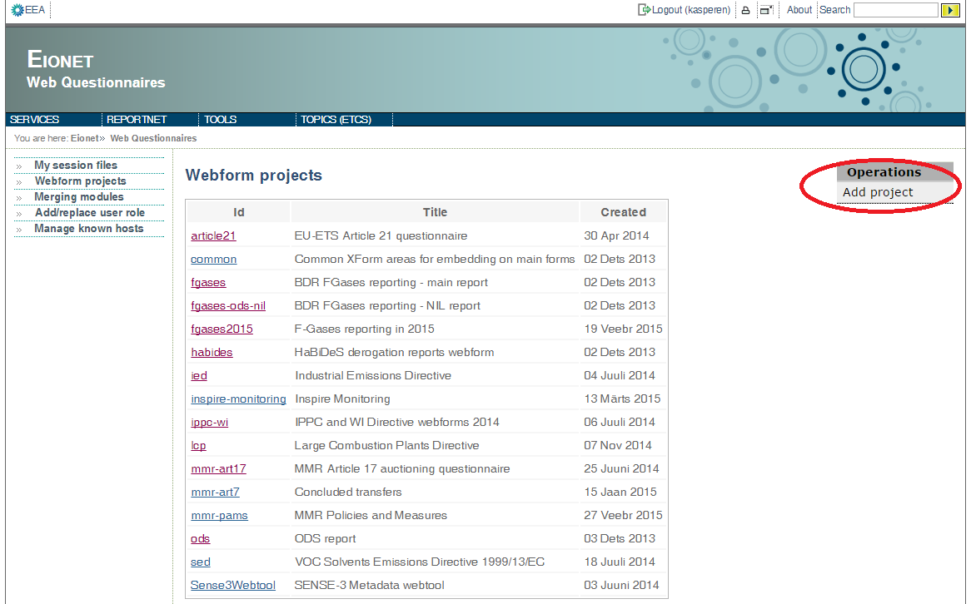Figure 1: Add webform project

View webform project folder
The webform project folder can contain two types of files – webforms and reference files (project files). Usually there are one webform and multiple reference files. The reference files uploaded into the project folder can hold Javascript, CSS, labels, codelists or other content referenced from the webform. They will be accessible from the same path as the webform.

See a sample screenshot of project folder in the next figure:
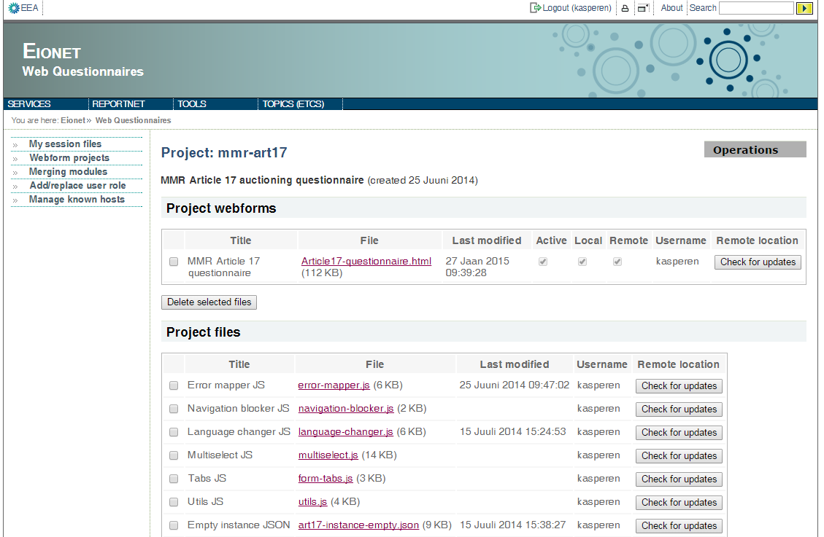Figure 2: Project folder of MMR Art17 webform

Upload webform
From the “Operations”-menu, now select “Add webform” and fill out the form - uploading your HTML or Xform webform and referencing the schema and empty instance file added before. WebQ uses file extension to detect automatically whether the uploaded file is XForm or HTML. The file name extension of Xform has to be *.xhtml, the other forms are handled as pure HTML forms.
Fill out the following fields to register you webfomr in WebQ service:
- Title – name of the webform to be able to distinguish the webforms in project folder
- WebForm – webform file. Has to be unique in project folder.
- Remote file URL – publicly accessible location of webform source code (eg in SVN). If the webform is publicly available over HTTP and the URL is registered in this field, then WebQ provides a functionality to update the source of the file in webforms repository with just one mouse click. Click on the button “Check for updates” in webforms project folder page to use this functionality.
- Description – short description about the intention of the webform
- XML Schema – the XML Schema location (eg. In Data Dictionary) of XML file allowed to edit on the webform. XML Schema uniquely identifies which XML files can be edited with this webform. The webform cannot be used if this field is not filled in or the value of XML Schema does not match with the value registered in CDR.
- New XML file name – the file name of newly created XML file by WebQ
- Empty instance XML Url – WebQ use sthis URL to grab the XML file and create it in the repository when user tries to open webform via WebQ front page.
- Active – tickbox for activating or deactivating the webform. If the checkbox is not ticket, then the webform is not visible either locally or in CDR.
- Local form – if ticket, then the webform can be used locally in WebQ system. The name of the webform is displayed on front page of WebQ when clicking “Create new session file”.
- Remote form – if ticket, then the webform can be used in CDR.
NB! to be able to successfully run the webform either locally or in CDR, please make sure that the following mandatory fields are filled in - XML Schema, XML file name, empty instance URL and the active, local and remote checkboxes are ticked.
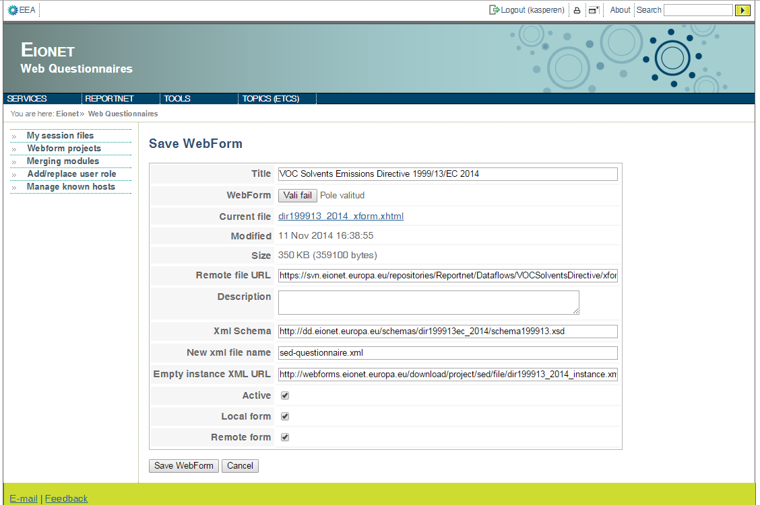Figure 3: Edit webform properties

Upload reference files
To add a reference file into webform project folder, click on “Add file” in Operations menu. Fill out the following fields:
- Title – name of the webform to be able to distinguish the webforms in project folder
- WebForm – webform file. Has to be unique in project folder.
- Remote file URL – publicly accessible location of file source code (eg in SVN). If the file is publicly available over HTTP and the URL is registered in this field, then WebQ provides a functionality to update the source of the file in project file repository with just one mouse click. Click on the button “Check for updates” in project folder page to use this functionality.
- Description – short description about the intention of the file
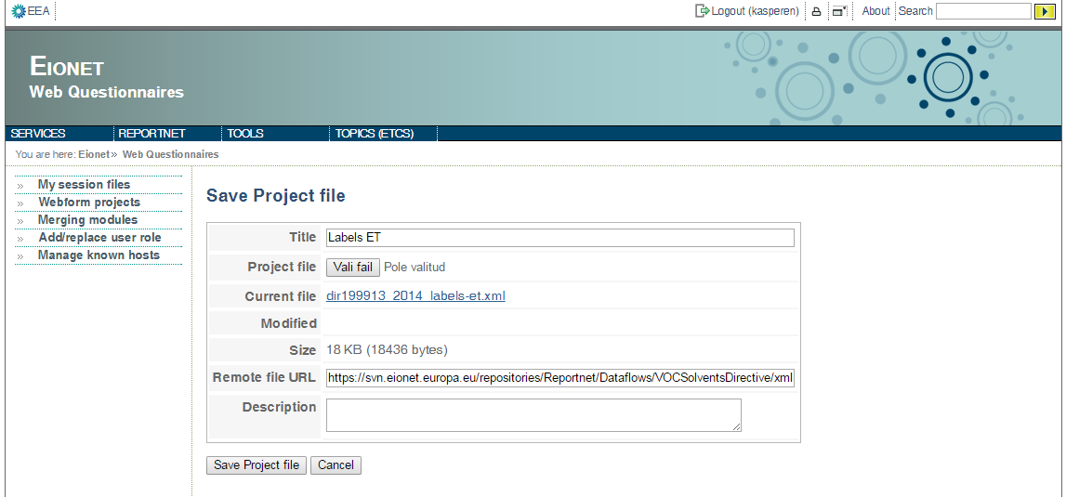Figure 4: Edit reference file properties

Test the webform in WebQ
Try out your newly added webform by selecting “My session files” from the menu to the left. Select “Create new session file”, choose the one added from the list, and select “Save file in session”. A new file will be added to your list of session files, which can be opened in your webform by selecting “Edit with '<your webform name>' web form” in the “Actions”-column.
Please remember, that the webform is only displayed in the selection, if you have inserted XML Schema, ticked Active and Local checkboxes on webform properties page.

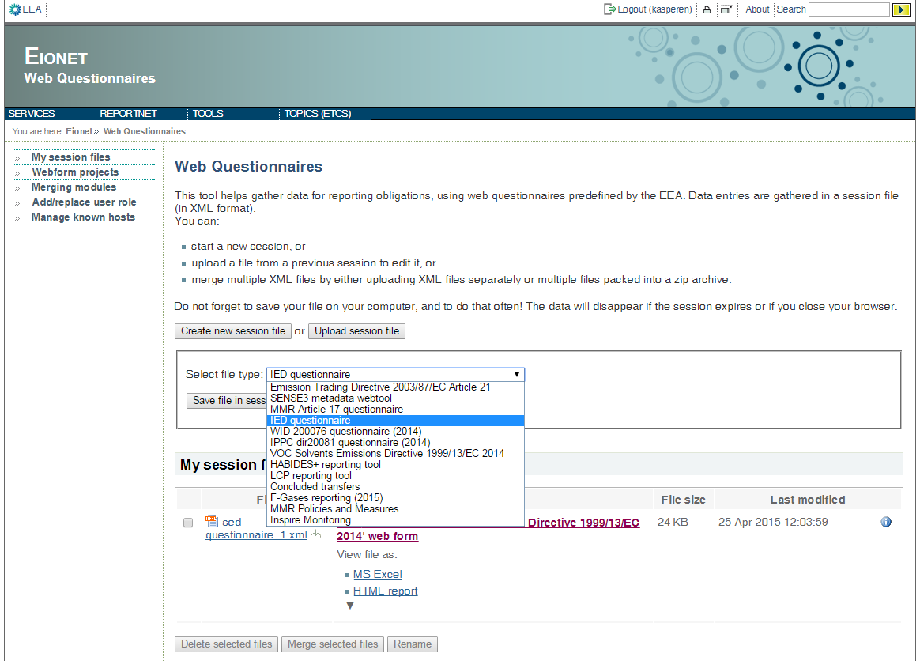Figure 5: Test the webform

Test the webform in CDR
To test the webform in CDR you first have to be sure that the DataflowMappings are updated in CDR management console and you have reporter privileges in CDR test system. Consult the stuff at EEA to achieve this. Navigate to the collection of the reporting obligation of any country and create a test envelope. You should see a “Add and edit … questionnaire” link in envelope draft page if everything is set up correctly.
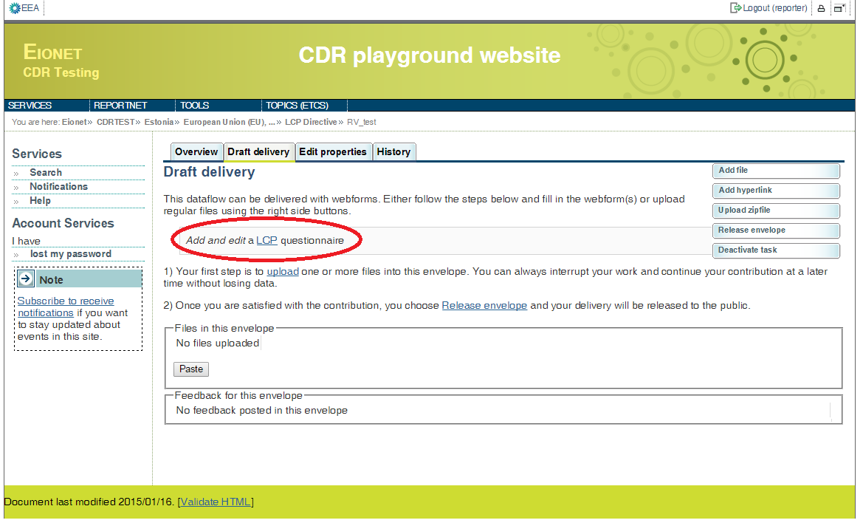Figure 6: CDR envelope draft page with a link to WebQ

Manage XML merging scripts
WebQ provides a functionality to merge XML files having the same XML schema. The functionality is available for both anonymous and authenticated users in WebQ session files area. If user has uploaded two files with the same XML Schema, then the merging option gets enabled as seen in the figure below.
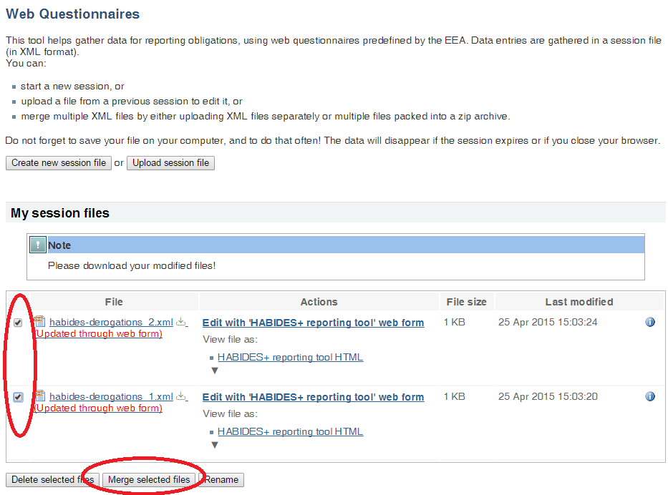Figure 7: Merge XML files
The merging functionality is available only when the dedicated merging module in XSLT language is implemented for the XML files and mapped with XML Schema. The merging modules management page is accessible in main menu “Merging modules”. The list of all available modules is displayed after opening the menu option. Click “Operations – Add merging module” to add a new module. Each merging module has to be mapped to one or several XML schemas.
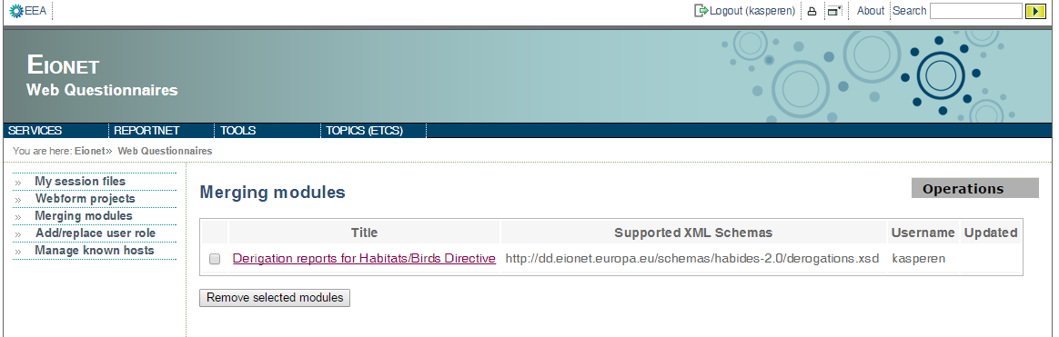Figure 8: Merging modules
The merging module is usually a simple XSLT file applied sequentially on selected XML files. Define the elements to be merged in XSLT file. See a sample XSLT underneath developed for HaBides xml file and merging all “derogation” elements
<xsl:stylesheet version="1.0" xmlns:xsl="http://www.w3.org/1999/XSL/Transform">
<xsl:output indent="yes"/>
<xsl:param name="secondFile"/>

<xsl:template match="/">
<derogations xmlns:xsi="http://www.w3.org/2001/XMLSchema-instance">
<xsl:attribute name="xsi:noNamespaceSchemaLocation">
<xsl:value-of select="derogations/@xsi:noNamespaceSchemaLocation"/>
</xsl:attribute>
<xsl:attribute name="country">
<xsl:value-of select="derogations/@country"/>
</xsl:attribute>
<xsl:attribute name="userIdentity">
<xsl:value-of select="''"/>
</xsl:attribute>
<xsl:attribute name="xml:lang">
<xsl:value-of select="derogations/@xml:lang"/>
</xsl:attribute>

<xsl:copy-of select="derogations/derogation"/>
<xsl:copy-of select="document($secondFile)/derogations/derogation"/>
</derogations>
</xsl:template>
</xsl:stylesheet>

Manage WebQ Service

Manage known hosts
WebQ uses data from known hosts table to download the data from restricted areas. If webform tries to download data from any URL, then WebQ first checks if the host of URL is registered as known host. WebQ adds the credential information to the request, only if the user is coming from CDR/BDR and he/she is authorised to use the webform.
Known hosts can be managed only by users with ADMIN permissions. Click on “Known hosts” in the left side menu to access all the records in known hosts table.
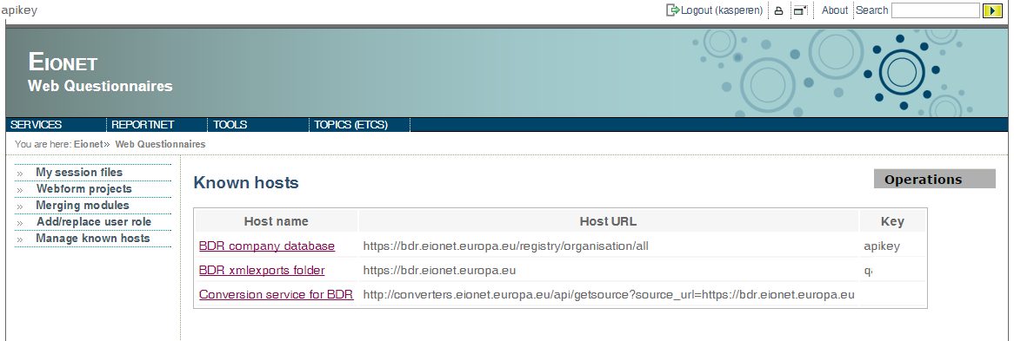
Click on the “Add known host” link in Operations menu to add a new host to the list.
The following properties has to be filled in for the known hosts:
- Host URL – URL of known host eg. Http://cdr.eionet.europa.eu
- Host name – Host name
- Auth method – authorisation mechanism: BASIC (http basic authentication in request header); REQUEST_PARAMETER (authentication key and value is added to URL as request paramater)
- Key/User name – request parameter name/user name to be added into http basic auth
- Ticket/Password – request parameter value/password to be added into http basic auth
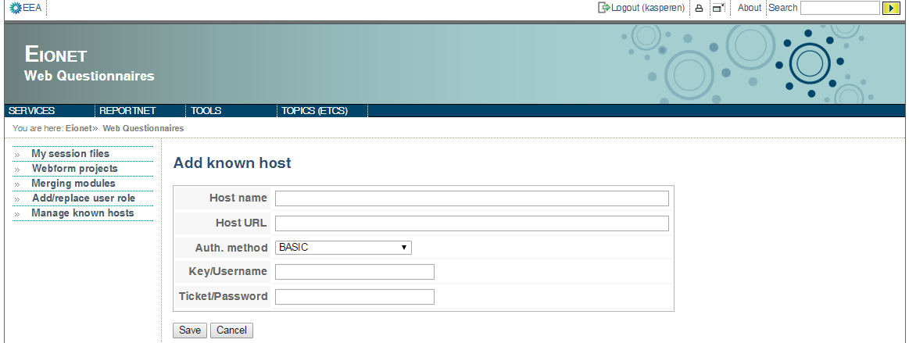Figure 9: Add known host

Manage users and roles
WebQ uses Spring Security role-based security mechanism. All users are assigned to roles and roles are privileged to perform actions in the system. The users and roles are stored in WebQ database tables USERs and AUTHORITIES. Only very basic functionality is implemented in the WebQ user interface to manage roles. Users in ADMIN role hve privileges to assign new users to ADMIN and DEVELOPER roles.
The future development need is to integrate the WebQ access control to AclAdmin tool https://github.com/eea/eionet.acladmin
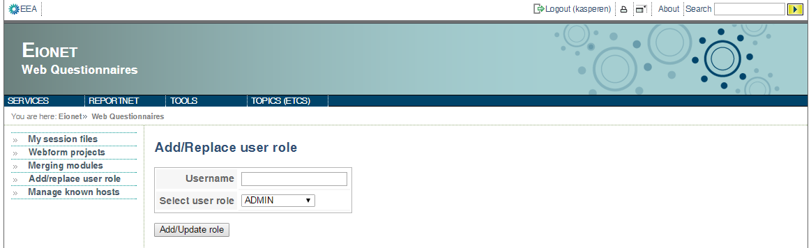Figure 10: Add users
API functions for webforms
External API functions
Integration with CDR/BDR

